PWM Volume Analyzer Process

An overview of the process beginning with a video clip and resulting in a plot of Volume over time:

1. Cut video segment down into a clip of suitable length
2. Extract stills from video file
3. Crop image sequence to channel dimensions in ImageJ
4. Run the ImageJ Volume_Analyzer macro
5. Process the results folder in Matlab
6. Compile ImageJ overlay images back into a video

## Cut video file down into a clip of suitable length

## Extract Still Frames from Video File (ffmpeg)

The recommended program for this is ffmpeg, which is command-line based. Copy the video clip into the folder where ffmpeg is located, then start a command prompt (Run > cmd) and navigate to the folder using the cd command followed by the location of the folder (copy/paste from Explorer):

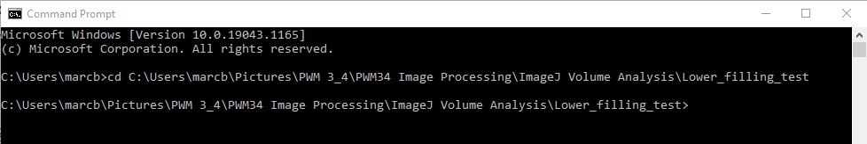

Now run ffmpeg using the following command, altering the highlighted text as needed:

ffmpeg -i videoclip.mp4 -vf fps=5 image-%05d.png

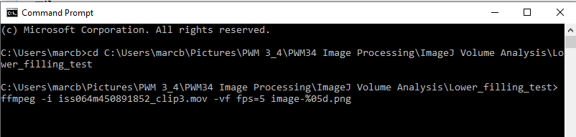

This command tells ffmpeg to export a frame at the prescribed framerate into the same folder. If you need to export more than 100,000 frames, change the number after the % symbol according to your needs. Additional options exist in ffmpeg, however personally I prefer to edit the clip using another tool then simply process the entire clip in ffmpeg for simplicity.

## Crop Image Sequence to Channel Dimensions (ImageJ)

Begin by opening FIJI, then choose File > Import > Image Sequence and navigate to the folder of frames created in the previous step.

Once the image sequence has loaded, rotate the image to horizontal using **Image > Transform > Rotate**

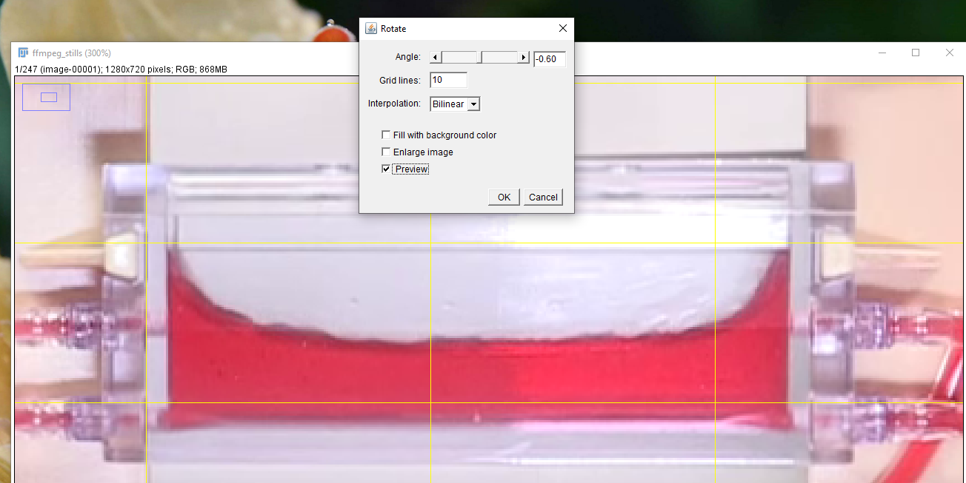

Next select the **rectangle tool** and draw a rectangle around the inner dimensions of the channel as shown below:

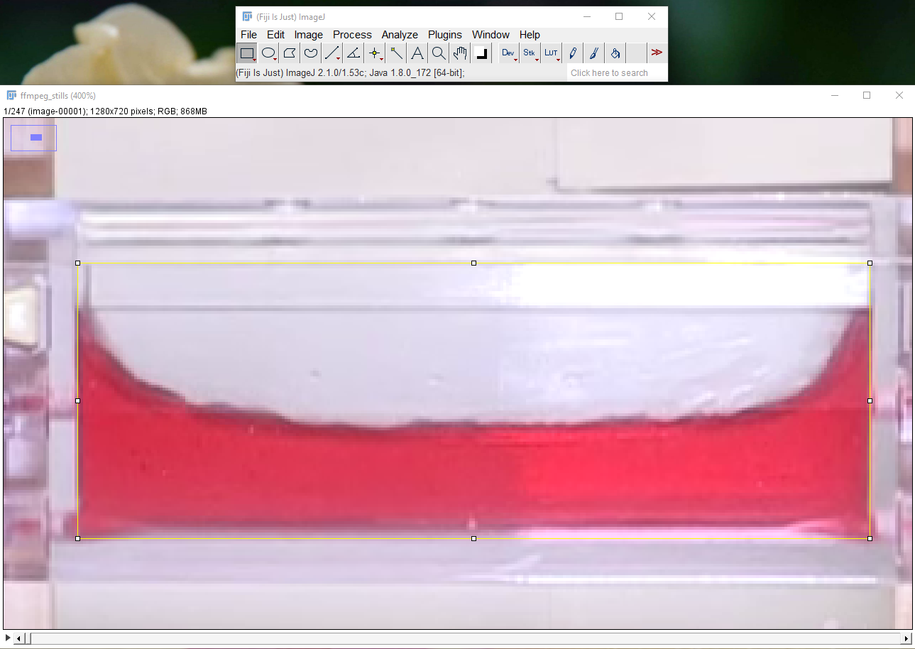

Next crop the image to the selection by using **Image > Crop**

Finally save the cropped images as a sequence of tiff or png images by **File > Save As > Image Sequence**. Choose options (some suggestions shown below), then navigate to a suitable location and click Save.

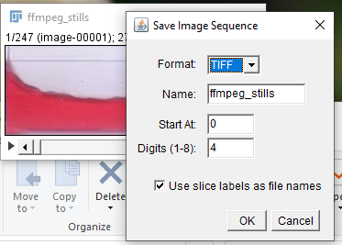

## Run the ImageJ Volume_Analyzer macro (ImageJ)

This is a custom macro which performs the following functions:

* Reads all the files in a selected folder
* For each file in the folder, the macro:
  + Selects the green color channel (provides best contrast for a red fluid)
  + Runs an automatic threshold function
  + Runs minor cleanup + creates an outlined binary image
  + Splits the image into n slices, where n is the number of points selected
  + Starting at the top for each slice, the program moves down until it finds the first black pixel in the binary image, which corresponds to the fluid surface
  + The program then creates a point here and moves to the next slice and repeats across the image
  + After creating n points, ImageJ saves the points as a .txt file into the folder called “Results_Output” and saves an image with the green channel and the thresholded image overlaid in the “Composites_Output” folder
* Below is a screenshot showing an example frame after it is processed:

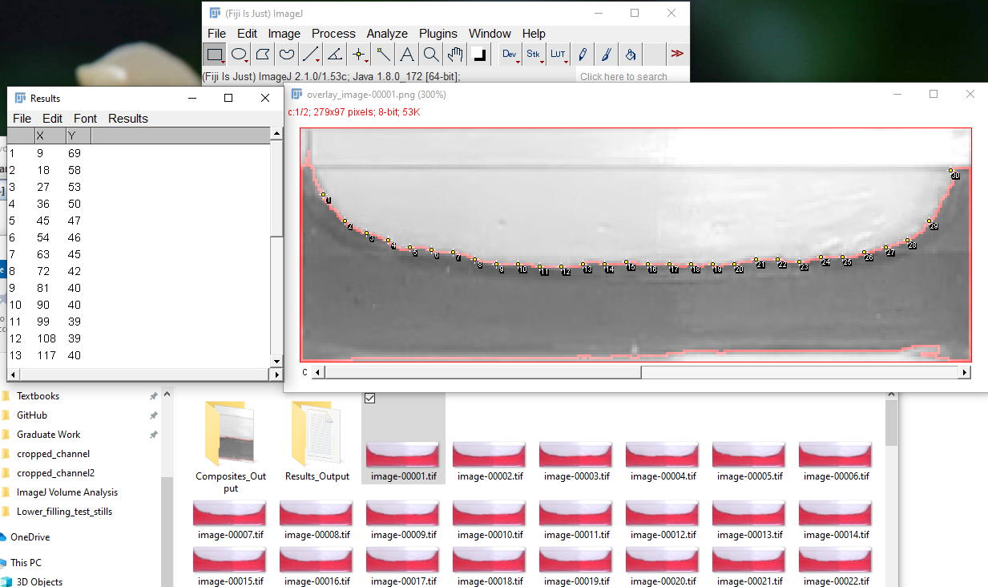

Run the macro in ImageJ/FIJI by going to **Plugins > Macros > Run** then choosing the macro file. It is the one that ends in “.ijm” suffix. When the macro opens, fill out the dialog box, click OK, then navigate to the cropped image sequence and select the first file.

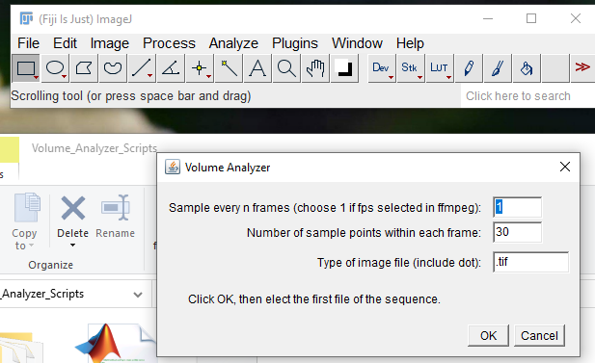

Wait while the macro runs. Try to avoid clicking anything in ImageJ as this can interrupt the macro and cause it to stop midway. When the macro has finished, you should receive a message stating how many files were processed:

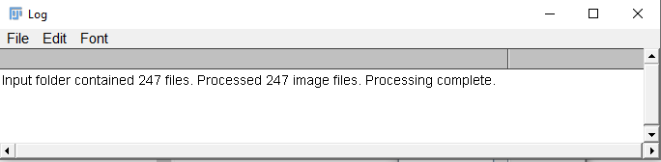

## Process the Results to Find the Volume (MATLAB)

Open Matlab and open the “PWM_Volume_Analyzer_MATLAB.m” file. Enter the required user-provided parameters at the top of the script:

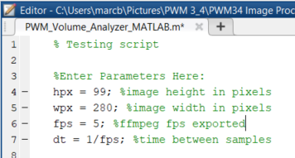

* **hpx** and **wpx**: right click on a single cropped image, click Properties, then choose the Details tab and record the height and width of the image in pixels here. Used to convert units.
* **fps**: enter the frames per second value used in ffmpeg
* **dt**: calculated from fps

Run the script. When prompted, navigate to the Results_Output folder created by ImageJ. When Matlab is done processing, you should see a plot appear with the volume change over time.

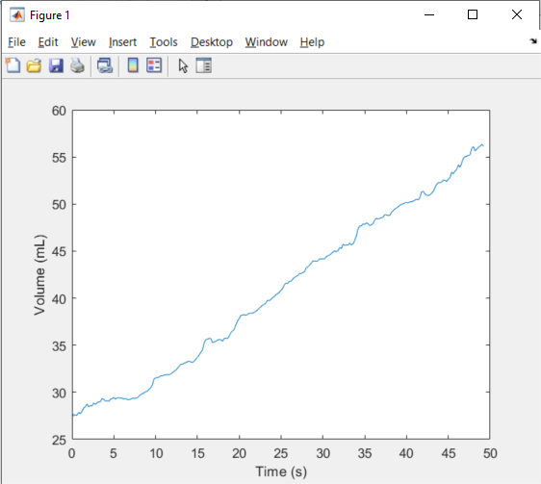

## Additional Processing Steps

### Create a Video From Overlay Images

Open a command prompt. Assuming a standard install, ffmpeg should be located in c:\ffmpeg. The command to create a video is shown below. Change the framerate to match the original rate in order to create a move of the same length as the original clip. Input file location and output file location should be changed in the command as well.

> “c:\ffmpeg\bin\ffmpeg.exe” -framerate 5 -i "<folder>\overlay_image-%05d.tif" “c:\users\marcb\videos\composite_video.mkv”

**Example with h264/mp4 video output:**

“c:\ffmpeg\bin\ffmpeg.exe” -framerate 5 -start_number 1 -i "c:\Users\marcb\Pictures\PWM 3_4\PWM34 Image Processing\ImageJ Volume Analysis\Lower_filling_test\cropped_channel2\Results_Output\Plot_Images\plot_frame_%d.tif" -vf "pad=ceil(iw/2)*2:ceil(ih/2)*2" -vcodec libx264 -pix_fmt yuv420p “c:\users\marcb\videos\plot_video.mp4”

**Example with uncompressed AVI output:**

“c:\ffmpeg\bin\ffmpeg.exe” -framerate 5 -start_number 1 -i "c:\Users\marcb\Pictures\PWM 3_4\PWM34 Image Processing\ImageJ Volume Analysis\Lower_filling_test\cropped_channel2\Composites_Output\overlay_image-%05d.png" “c:\users\marcb\videos\channel_overlay_video.avi”